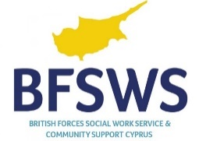

Multi-Agency Referral Form

Please use this form whenever you are contacting us regarding a child, young person or vulnerable adult. If you need advice before completing this form, please get in touch with your local Social Worker to discuss further. Please complete this form as far as possible.

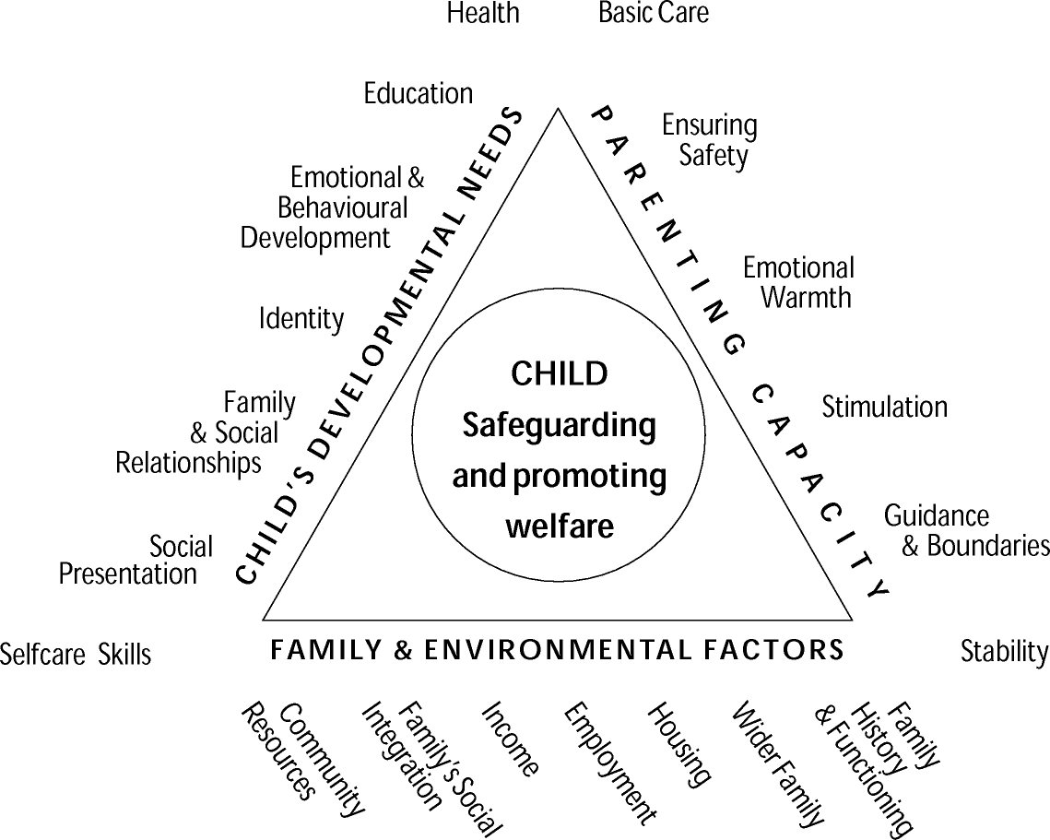

Referrer’s details
Date of this Notification |  | Landline telephone
Name |  | Mobile telephone
Role & Relationship to child/young person/vulnerable adult |  | When available to discuss the Referral
Address
Please given an alternative name of who to contact in case you (the referrer) are unavailable

About the child/young person/vulnerable adult
Surname |  | Home Address
First Name
Date of Birth |  | Current Address if different, or Military Unit
Gender
Ethnicity

Landline telephone |  | Mobile telephone
Religion |  | Nationality
First Language |  | Disability
Second Language |  | Communication Needs

Consent
Does the person with Parental Responsibility (PR) for the Child/Young person know that you are contacting us?
Yes No
The person with Parental Responsibility should be informed unless there are clear Child Protection concerns. This department will not accept referrals which do not have parental knowledge unless there are clear risks to the child for not doing so. If you are in any doubt please contact your local Social Worker.
If you have not obtained consent, please explain why

Details of concerns
Please include the following:
- why you are contacting us regarding this child/young person/vulnerable adult
- what are the risks to the child/young person/vulnerable adult
- if so, what type of harm the child/young person/vulnerable adult is suffering or likely to be suffering
- if so, any disclosures including who made a disclosure and when
- how in your opinion this impacts on the child or vulnerable adult’s health and/or development
- any previous concerns or relevant background information
- any action you have taken to date, when and what outcome
- parents’ capacity to meet child’s needs adequately
- other agencies intervention with the child/family
- your comments on the intervention you believe to be necessary

THIS MUST BE DETAILED AND EVIDENCE BASED
What are you worried about?
What is going well for the child/vulnerable adult (that might reduce the risks)?
What service(s) do you think is/are required to change the things you are worried about?
(Continue on a separate sheet if necessary)

Person who is harming or putting this child/young person at risk
Please complete this only if applicable
Name |  | Address
Relationship to the child/vulnerable adult
Date of Birth |  | Telephone

Risks
Based on the information provided above, please tell us your
opinion of the level of risk to the child/vulnerable person. Low Medium High
Please detail explicitly your reasoning for this: -

What is the nature of the risk: -
Emotional Sexual Physical Neglect

About the child / young person’s parents
 | Mother | Father
Rank/Title
Name
Regiment/Unit
Entitled Personnel? | Yes/No | Yes/No
Service Number
Date of birth
Tourex Date
Address
Telephone
* Telephone numbers are compulsory*

About the child’s main carer(s)
Please complete this section only if the parents are not the main carers of the child
 | Main Carer 1 | Main Carer 2
Rank/Title
Name
Regiment/Unit
Entitled Personnel? | Yes/No | Yes/No
Service Number
Date of birth
Tourex Date
Address
Telephone
* Telephone numbers are compulsory*

About the child/young person/vulnerable adult’s brothers and sisters and all children to be included in the assessment?

Is this a family issue?
 | Sibling 1 | Sibling 2
Full name
Gender
Date of birth
Address
Ethnicity
(Please continue on a separate sheet if necessary)

Early Help Assessments (EHA)
Has an EHA been completed? Yes No
If you have obtained consent to share the EHA please attach a copy.
If an EHA has been completed, what was the outcome?

If an EHA has not been completed – why?

Any other known professional involvement
Type | Agency, Address, Telephone | Contact Name

Signature:
Name:
Date:
Once this form is completed, please send to: contactuscyprus@forcessocialwork.com

